**Displaying all the available teams**

**Step 1: create a human service which is having server script for team creation, coach to display the team and team members.**

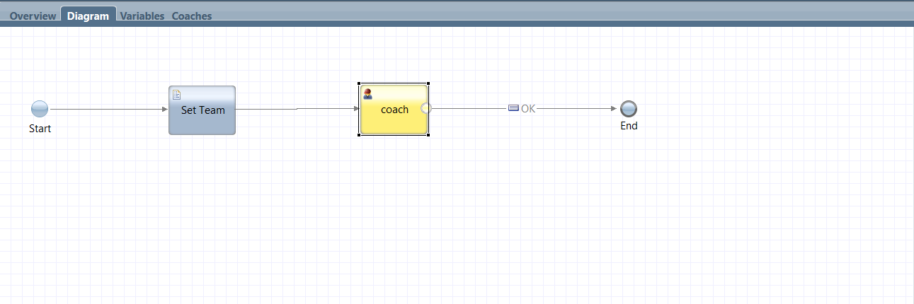

**Step2: In variable section, declare private variables Team, Team members (list) and selteam.** 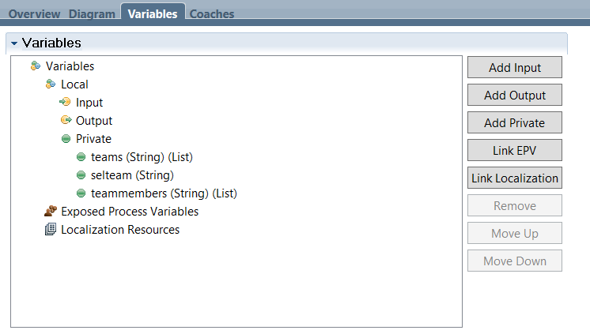

**Step3: In server script we need to write declare the team list.**

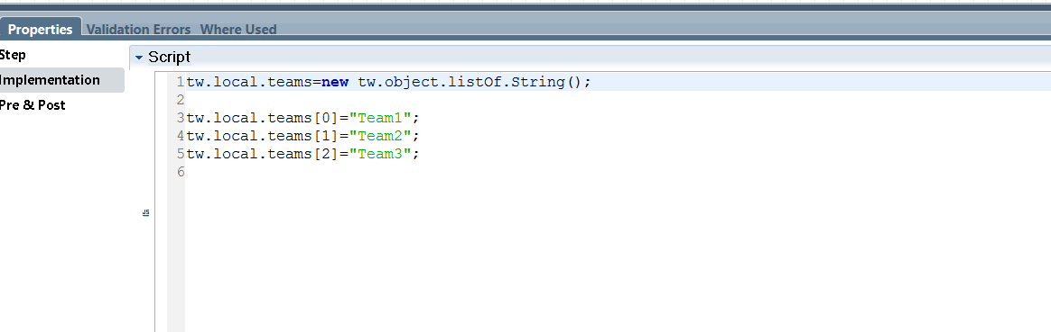

**Step4: Here we need to drag team variable from palette and drop to coach, we need to add section in that we need to take output text, to display the team members, and we need to drag and drop created coach view to coach to retrieve team members.**

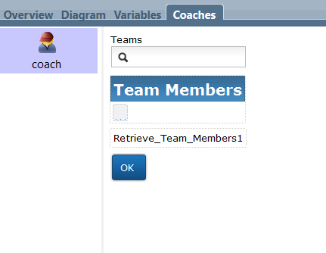

**Step5: In the Teams (single select) we need to bind selteam variable in general properties.**

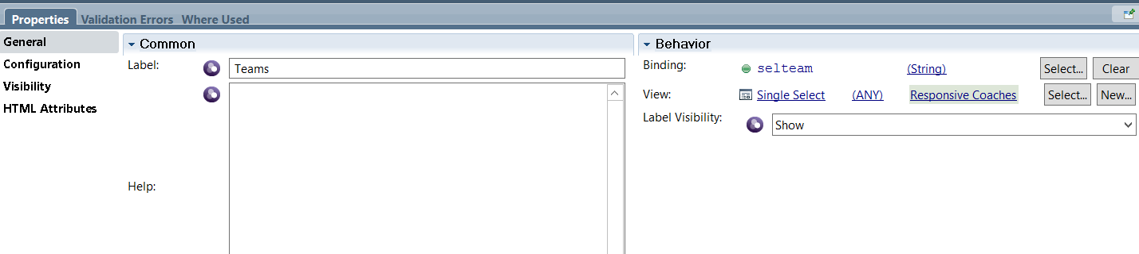

**Step6: In the teams (single select) we need to select team list variable in configuration properties.**

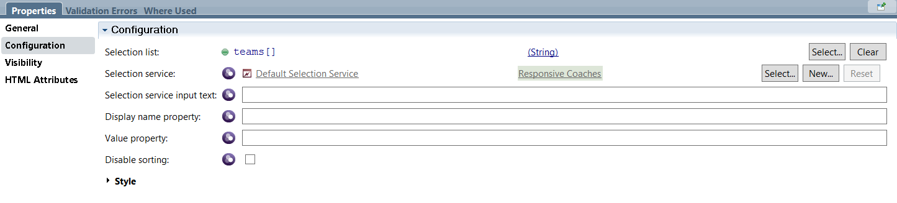

**Step7: In the Team Members (section) we need to bind Team Members list in general properties.**

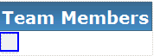

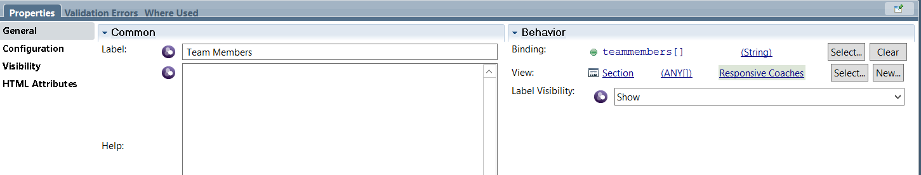

**Step8: In the output text which is within the horizontal section we need bind team members current item variable in general properties.**



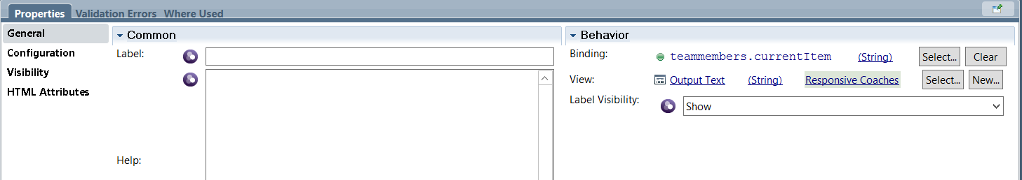

**Step9: Retrieve_Team_Members1 is the created coach view we need to drag from palette and drop it to coach.**

**In the configuration properties we need to select team and we need to bind Ajax service for created team members in team service.**

**In the members list we need to bind team members list in configuration properties.**



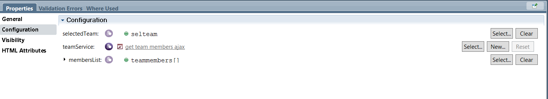

**Step10: In coach view we need to create variables in configuration options, for team service variable we need to add created Ajax service to it.**

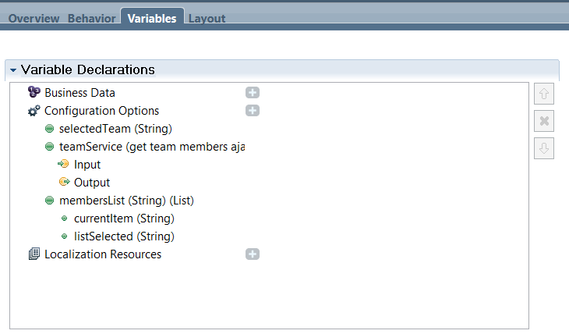

**Step11: In the behavior of coach view we need to write change function in event handlers.**

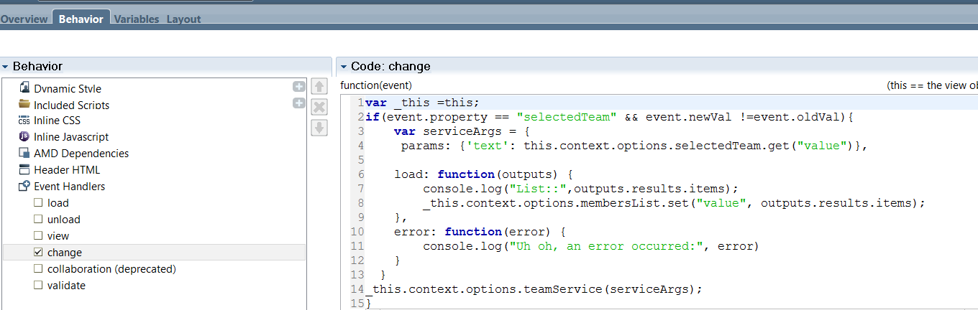

**Step12: After running the human service it will display team’s dropdown if we select team it will display the members within it.**

